**Question 3.1.a**

**Using the same data set (credit_card_data.txt or credit_card_data-headers.txt) as in Question 2.2, use the ksvm or kknn function to find a good classifier:**

**(a) using cross-validation (do this for the k-nearest-neighbors model; SVM is optional);**

**Answer:**

To start with Cross Validation, we need perform the following steps.

**Step 1:** Activate the libraries

**CODE:**

*setwd("D:/MS Georgia Tech/Introduction to Analytics/HW2")*

*library(kernlab)*

*library(kknn)*

*install.packages(“dplyr”)*

*library(dplyr)*

*set.seed(1)*

**Step 2:** Load the data in R data frame.

**CODE:**

*ccdata <- read.table("credit_card_data-headers.txt", stringsAsFactors = FALSE, header = TRUE)*

*glimpse(ccdata)*

**OUTPUT:**

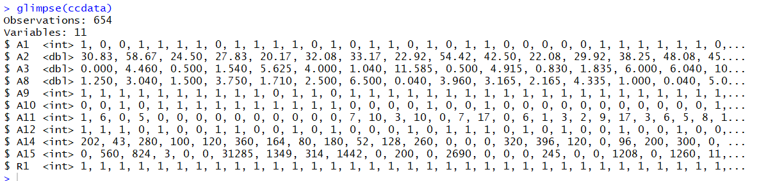

**Step 3:** Using train.kknn to perform leave-one-out cross-validation

**CODE:**

# kernel choices

kern <- c("rectangular","triangular","epanechnikov","biweight","triweight","cos","inv","gaussian","optimal")

# pick a maximum k (number of neighbors) of 100

k_max <- 100

# distances to try

dist<-c(1,2,3,4,5,6,7,8,9,10)

model <-for (distances in dist) {

mod<-train.kknn(R1~.,ccdata,kmax=k_max,distance=distances,kernel=kern,scale=TRUE)

print(distances)

print(mod)

}

**OUTPUT:**

[1] 1

Call:

train.kknn(formula = R1 ~ ., data = ccdata, kmax = k_max, distance = distances, kernel = kern, scale = TRUE)

Type of response variable: continuous

minimal mean absolute error: 0.1880734

Minimal mean squared error: 0.1048715

Best kernel: triweight

Best k: 74

[1] 2

Call:

train.kknn(formula = R1 ~ ., data = ccdata, kmax = k_max, distance = distances, kernel = kern, scale = TRUE)

Type of response variable: continuous

minimal mean absolute error: 0.1850153

Minimal mean squared error: 0.1061155

Best kernel: inv

Best k: 22

[1] 3

Call:

train.kknn(formula = R1 ~ ., data = ccdata, kmax = k_max, distance = distances, kernel = kern, scale = TRUE)

Type of response variable: continuous

minimal mean absolute error: 0.1896024

Minimal mean squared error: 0.107919

Best kernel: biweight

Best k: 91

[1] 4

Call:

train.kknn(formula = R1 ~ ., data = ccdata, kmax = k_max, distance = distances, kernel = kern, scale = TRUE)

Type of response variable: continuous

minimal mean absolute error: 0.1880734

Minimal mean squared error: 0.1084085

Best kernel: biweight

Best k: 98

[1] 5

Call:

train.kknn(formula = R1 ~ ., data = ccdata, kmax = k_max, distance = distances, kernel = kern, scale = TRUE)

Type of response variable: continuous

minimal mean absolute error: 0.1865443

Minimal mean squared error: 0.1087676

Best kernel: biweight

Best k: 88

[1] 6

Call:

train.kknn(formula = R1 ~ ., data = ccdata, kmax = k_max, distance = distances, kernel = kern, scale = TRUE)

Type of response variable: continuous

minimal mean absolute error: 0.1850153

Minimal mean squared error: 0.1090389

Best kernel: biweight

Best k: 92

[1] 7

Call:

train.kknn(formula = R1 ~ ., data = ccdata, kmax = k_max, distance = distances, kernel = kern, scale = TRUE)

Type of response variable: continuous

minimal mean absolute error: 0.1850153

Minimal mean squared error: 0.109183

Best kernel: biweight

Best k: 83

[1] 8

Call:

train.kknn(formula = R1 ~ ., data = ccdata, kmax = k_max, distance = distances, kernel = kern, scale = TRUE)

Type of response variable: continuous

minimal mean absolute error: 0.1880734

Minimal mean squared error: 0.1093045

Best kernel: biweight

Best k: 82

[1] 9

Call:

train.kknn(formula = R1 ~ ., data = ccdata, kmax = k_max, distance = distances, kernel = kern, scale = TRUE)

Type of response variable: continuous

minimal mean absolute error: 0.1865443

Minimal mean squared error: 0.1094212

Best kernel: biweight

Best k: 85

[1] 10

Call:

train.kknn(formula = R1 ~ ., data = ccdata, kmax = k_max, distance = distances, kernel = kern, scale = TRUE)

Type of response variable: continuous

minimal mean absolute error: 0.1880734

Minimal mean squared error: 0.1095125

Best kernel: biweight

Best k: 85

distance 7 8 9 10

call Expression Expression Expression Expression

terms Expression Expression Expression Expression

data List,11 List,11 List,11 List,11

**ANALYSIS: The best model is the model with lowest Minimal Mean Squared Error. If you look at the complete output above, it appears that lowest Minimal Mean Squared Error is 0.1048715 for distance = 1. So for the output with distance = 1, K = 74 which would be the best value of K.**

**CODE:**

*# The best model set is distance=1 with k=74 and kernel=triweight (lowest minimal mean squared error)*

*model1 <- train.kknn(R1~., ccdata, kmax=100, distance=1,scale = TRUE, kernel=kern)*

*model1*

**OUTPUT:**

Call:

train.kknn(formula = R1 ~ ., data = ccdata, kmax = 100, distance = 1, kernel = kern, scale = TRUE)

Type of response variable: continuous

minimal mean absolute error: 0.1880734

Minimal mean squared error: 0.1048715

Best kernel: triweight

Best k: 74

**Using the same data set (credit_card_data.txt or credit_card_data-headers.txt) as in Question 2.2, use the ksvm or kknn function to find a good classifier:**

**(b) splitting the data into training, validation, and test data sets (pick either KNN or SVM; the other is optional).**

**Answer:**

In order to split the data with ration of 60%:20%:20% where 60% belongs to training set, 20% belongs to testing set and 20% belongs to validation.

**Step 1:** This step is for calculating Testing data

**CODE:**

*set.seed(1)*

*# pulling 20% indexes of random data points in the data set*

*test.indices = sample(1:nrow(ccdata), round(.2*nrow(ccdata)), replace=FALSE)*

*# pulling data for those indexes*

*test = ccdata[test.indices,]*

*nrow(test)*

The test dataset generates 131 records

**Step 2:** This step is for calculating Validation data

**CODE**:

*# the remainder of the data besides that which was set aside for testing*

*validfortraining = ccdata[-test.indices,]*

*# 20% for validation (25% of 80% is 20%)*

*validation.indices = sample(1:nrow(validfortraining), round(.25*nrow(validfortraining)), replace=FALSE)*

*validation = validfortraining [validation.indices,]*

*nrow(validation)*

The validation dataset generates 131 records

**Step 3:** This step is for calculating Training data

**CODE**:

*# The remainder of the data -- 80% -- is for training*

*train = as.data.frame(validfortraining[-validation.indices,])*

*nrow(train)*

The train dataset generates 392 records

**Step 4:** Find the best value of K

**CODE:**

*# kernel choices*

*kern <- c("rectangular","triangular","epanechnikov","biweight","triweight","cos","inv","gaussian","optimal")*

*# pick a maximum k (number of neighbors) of 100*

*k_max <- 100*

*# distances to try*

*dist<-c(1,2,3,4,5,6,7,8,9,10)*

*model <-for (distances in dist) {*

*mod<-train.kknn(R1~.,train,kmax=k_max,distance=distances,kernel=kern,scale=TRUE)*

*print(distances)*

*print(mod)*

*}*

**OUTPUT:**

[1] 1

Call:

train.kknn(formula = R1 ~ ., data = train, kmax = k_max, distance = distances, kernel = kern, scale = TRUE)

Type of response variable: continuous

minimal mean absolute error: 0.1989796

Minimal mean squared error: 0.1114249

Best kernel: rectangular

Best k: 14

[1] 2

Call:

train.kknn(formula = R1 ~ ., data = train, kmax = k_max, distance = distances, kernel = kern, scale = TRUE)

Type of response variable: continuous

minimal mean absolute error: 0.1938776

Minimal mean squared error: 0.1146717

Best kernel: inv

Best k: 17

[1] 3

Call:

train.kknn(formula = R1 ~ ., data = train, kmax = k_max, distance = distances, kernel = kern, scale = TRUE)

Type of response variable: continuous

minimal mean absolute error: 0.188792

Minimal mean squared error: 0.1167837

Best kernel: inv

Best k: 17

[1] 4

Call:

train.kknn(formula = R1 ~ ., data = train, kmax = k_max, distance = distances, kernel = kern, scale = TRUE)

Type of response variable: continuous

minimal mean absolute error: 0.1960027

Minimal mean squared error: 0.1166515

Best kernel: inv

Best k: 18

[1] 5

Call:

train.kknn(formula = R1 ~ ., data = train, kmax = k_max, distance = distances, kernel = kern, scale = TRUE)

Type of response variable: continuous

minimal mean absolute error: 0.1964286

Minimal mean squared error: 0.1177008

Best kernel: inv

Best k: 17

[1] 6

Call:

train.kknn(formula = R1 ~ ., data = train, kmax = k_max, distance = distances, kernel = kern, scale = TRUE)

Type of response variable: continuous

minimal mean absolute error: 0.1938776

Minimal mean squared error: 0.117866

Best kernel: inv

Best k: 19

[1] 7

Call:

train.kknn(formula = R1 ~ ., data = train, kmax = k_max, distance = distances, kernel = kern, scale = TRUE)

Type of response variable: continuous

minimal mean absolute error: 0.1938776

Minimal mean squared error: 0.1188797

Best kernel: inv

Best k: 18

[1] 8

Call:

train.kknn(formula = R1 ~ ., data = train, kmax = k_max, distance = distances, kernel = kern, scale = TRUE)

Type of response variable: continuous

minimal mean absolute error: 0.1938776

Minimal mean squared error: 0.1192697

Best kernel: inv

Best k: 19

[1] 9

Call:

train.kknn(formula = R1 ~ ., data = train, kmax = k_max, distance = distances, kernel = kern, scale = TRUE)

Type of response variable: continuous

minimal mean absolute error: 0.1938776

Minimal mean squared error: 0.120359

Best kernel: triangular

Best k: 41

[1] 10

Call:

train.kknn(formula = R1 ~ ., data = train, kmax = k_max, distance = distances, kernel = kern, scale = TRUE)

Type of response variable: continuous

minimal mean absolute error: 0.1870234

Minimal mean squared error: 0.1205148

Best kernel: triangular

Best k: 41

**ANALYSIS: The output with distance = 1 has the lowest minimal mean squared error. So the best Kernel = rectangular and best K = 14**

**Given below is the code to calculate accuracy. We first run the model on the test and validation data.**

**CODE:**

*model2 <- kknn(train$R1~train$A1+train$A2+train$A3+train$A8+train$A9+train$A10+train$A11+train$A12+train$A14+train$A15,*

*validation, test, distance=1, kernel="rectangular",k=14,scale=TRUE)*

*# how well does the model predict the response variable?*

*predknn = model2$fitted.values*

*sum(predknn == train$R1) / nrow(test)*

**OUTPUT:**

0.740458

The model is 74.04% accurate.

**Question 4.1**

**Describe a situation or problem from your job, everyday life, current events, etc., for which a clustering model would be appropriate. List some (up to 5) predictors that you might use.**

**Answer:**

I was once working on a project and the data set given to us was a dataset of sales in the apparel industry. It had data for companies like, GAP, Old Nay, Banana Republic, Abercrombie and Fitch, Hollister etc. We were supposed to give some business recommendation after analysis of the data. As a part of the project we applied association rules algorithm to the data using a tool called as XL Miner and we found out that Gap was Highly associated to Old Navy. Though they were sister brands, GAP was losing all its customers to Old Navy.

In a situation like this we used clustering to raise the sales of GAP so that it would not lose its customers to Old Navy or other brands. We categorized the customers that visit GAP into 3 clusters. Given below are the details of the clusters.

Cluster 1 was named as GRAZERS.

1. Education is low may be have just completed school.
2. Age is moderate to high compared to other clusters.
3. Income is Moderate due to profession or they are retired.
4. As the income is moderate their expenditure is moderate.
5. House hold size is relatively high as they have a close-knit family.

Cluster 2 was named as BARGAIN HUNTERS.

1. Education is moderate as they are either in College or Graduating.
2. Age is lowest among all clusters.
3. Income is low as they are either doing an On-Campus job or doing an Internship.
4. Expenditure is low as their income is low; they always hunt for Best Deals.
5. House hold size is lowest as they are teenagers.

Cluster 3 was named as HIGH ROLLERS.

1. Education is highest among all clusters.
2. Age is quite moderate.
3. Income is highest among all clusters which can be derived from their profession.
4. Expenditure is highest as their income is very high.
5. House hold size is relatively high as they have a close-knit family.

**Question 4.2**

**The iris data set iris.txt contains 150 data points, each with four predictor variables and one categorical response. The predictors are the width and length of the sepal and petal of flowers and the response is the type of flower. The data is available from the R library datasets and can be accessed with iris once the library is loaded. It is also available at the UCI Machine Learning Repository (https://archive.ics.uci.edu/ml/datasets/Iris ). The response values are only given to see how well a specific method performed and should not be used to build the model.**

**Use the R function kmeans to cluster the points as well as possible. Report the best combination of predictors, your suggested value of k, and how well your best clustering predicts flower type.**

**Answer:**

**Given below are the steps performed to eventually find the best value of k.**

**Step 1: Load all libraries.**

**CODE:**

*rm(list = ls())*

*set.seed(1)*

*library(datasets)*

*library(ggplot2)*

*install.packages("corrplot")*

*library(corrplot)*

*library(gridExtra)*

**Step 2: Load the IRIS dataset into the dataframe**

**CODE:**

*iris = read.delim("iris.txt")*

**Step 3: Analysis for best value of K**

We can plot the variables in four different ways using color to represent the species in the data set.

The 4 ways are

1. Petal Length vs Petal Width
2. Sepal Length vs Sepal Width
3. Sepal Length vs Petal Length
4. Petal Width vs Sepal Width

**CODE:**

*# visualize the data*

*plot1 <- ggplot(iris, aes(Petal.Length, Petal.Width, color=Species)) + geom_point()*

*plot2 <- ggplot(iris, aes(Sepal.Length, Sepal.Width, color=Species)) + geom_point()*

*plot3 <- ggplot(iris, aes(Sepal.Length, Petal.Length, color=Species)) + geom_point()*

*plot4 <- ggplot(iris, aes(Petal.Width, Sepal.Width, color=Species)) + geom_point()*

*grid.arrange(plot1,plot2,plot3,plot4,nrow=2)*

**OUTPUT:**

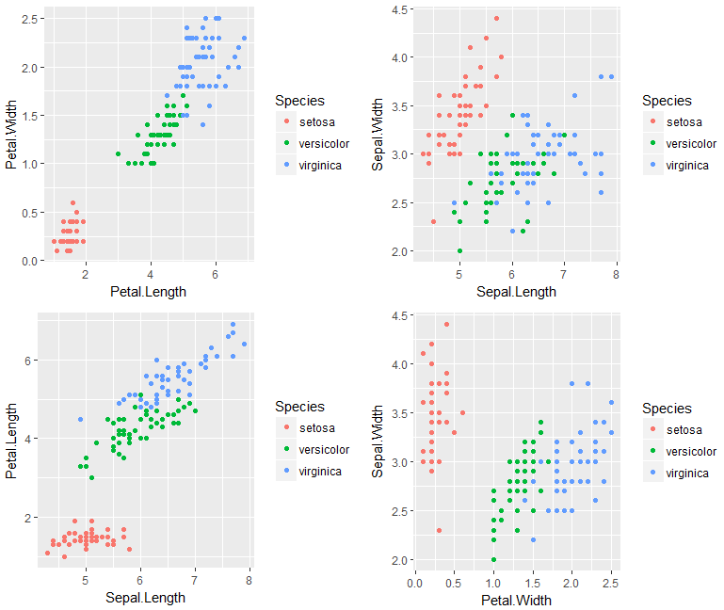

Looking at the plot above, it suggests that the plots with sepal width and Sepal Length (right plot above) are not so helpful for clustering of data.

We can also plot the correlations between each variable and see if we can find any relationships.

**CODE:**

*# correlation between any two variables*

*corrplot(cor(iris[,1:4]))*

**OUTPUT:**

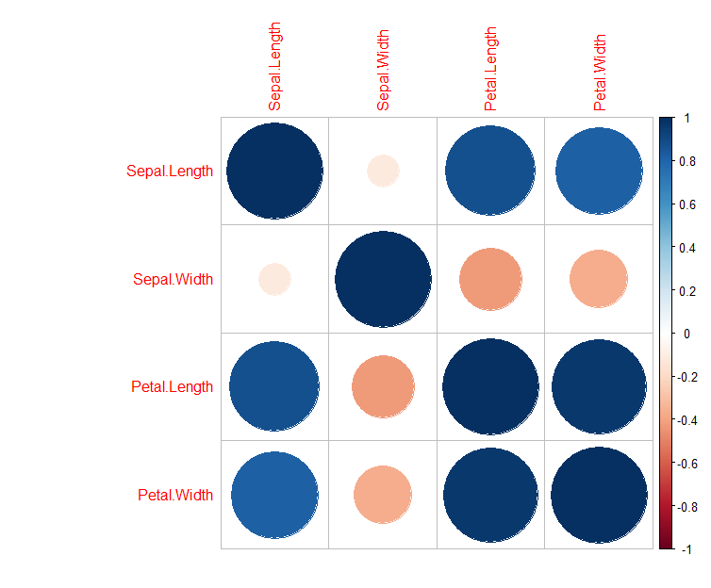

Looking at the plot above Sepal Width does not appear to be helpful as it does not have a good correlation with the other fields. So we can stop considering Sepal Width.

So we use the Kmeans function in R using Sepal Length, Petal Length and Petal Width. We will iterate through multiple values of K and store the data in a vector named km

**CODE:**

*km <- c()*

*for (k in 1:10){*

*m <-kmeans(cbind(iris[,1],iris[,3:4]),k,nstart=20,iter.max=20)*

*km[k] = (m$tot.withinss)*

*}*

*km*

**OUTPUT:**

km

[1] 653.06367 131.88039 63.34212 42.19179 31.64576 27.31261 23.39318 19.61958 17.94542 16.35759

Now we can plot our diagram and see what value of k would work best for our k means clustering.

**CODE:**

*plot_best <- as.data.frame(cbind(k=1:10,SumOfSquares=km))*

*gg_best <- ggplot(plot_best,aes(x=k,y=SumOfSquares)) + geom_point(color="red") + geom_line(color="red") + ggtitle("Sepal.Length, Petal.Length, and Petal.Width")*

*plot(gg_best)*

**OUTPUT:**

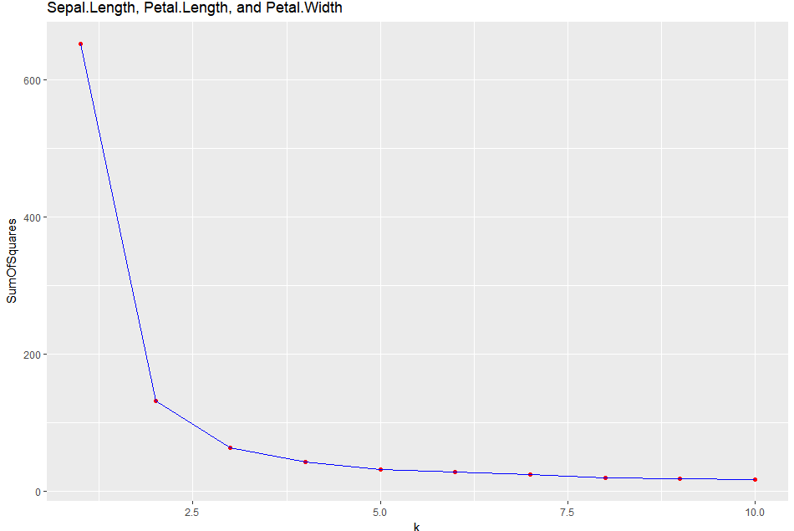

**Analysis:** Looking at the elbow diagram above, it appears that K = 3 is the best choice.

So choosing K = 3 from elbow diagram

**CODE:**

# choosing k=3 from the elbow diagram

km_3 <- kmeans(cbind(iris[,1],iris[,3:4]),3,nstart=20)

table(km_3$cluster,iris$Species)

**OUTPUT:**

setosa versicolor virginica

1 0 2 36

2 50 0 0

3 0 48 14